Coreference Resolution

Source: https://people.ischool.berkeley.edu/~dbamman/nlp20_slides/20_coreference.pdf

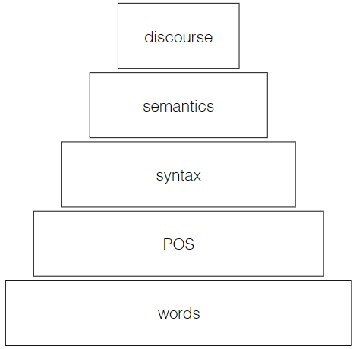
Discourse
  - Linguistics beyond single sentence
  - Coreference
    - Find instances with same referent
    - English constraints: number/gender/person
    - Candidate mentions: recall more important than precision
    - Mention-ranking models perform coreference as each decision over mention
    - Nature of identity makes coreference complex as entities in texts can change

Evaluation
- Precision:
- Recall:

